WEEK 3 REPORT
Advanced Data Analysis and Visualization in Logistics
Project Title: Logistics Delivery Performance Analysis and Route Optimization Using Python
Dataset: DataCo Supply Chain Dataset
Reporting Week: Week 3

1. Introduction
During Week 3, advanced data analysis and visualization were performed on the DataCo Supply Chain Dataset to understand logistics operations, delivery performance, sales distribution, and shipping efficiency.
The cleaned dataset was analyzed using Python libraries, including Pandas, NumPy, Matplotlib, and Seaborn. Statistical calculations, grouping, correlation analysis, and graphical visualizations were used to identify patterns and potential problems in logistics operations.
The main focus was to evaluate delivery performance, compare shipping modes, identify high-risk markets and regions, and analyze product categories based on sales, profit, and delivery delays.
2. Objectives
The main objectives of Week 3 were:
- Perform descriptive statistical analysis on numerical columns.
- Compare actual shipping time with scheduled shipping time.
- Analyze delivery status and calculate key performance indicators (KPIs).
- Examine sales performance across different shipping modes.
- Identify shipping modes with high late-delivery rates.
- Analyze delivery performance across markets and regions.
- Identify high-risk regions with late-delivery rates above 50%.
- Evaluate product categories based on sales, profit, and delivery performance.
- Create visualizations to communicate important findings.
- Provide recommendations to improve logistics performance.
3. Dataset Overview
The analysis used the cleaned DataCo Supply Chain Dataset.
Dataset Detail | Description
Original records | 180,519
Original fields | 53
Cleaned records | 180,519
Cleaned fields | 46
File used | clean_logistics_data.csv
Data format | CSV
Main areas | Orders, customers, products, sales, shipping, delivery, profit, markets and regions
The dataset includes important fields such as Delivery Status, Late_delivery_risk, Days for shipping (real), Days for shipment (scheduled), Sales, Order Profit Per Order, Shipping Mode, Market, Order Region, and Category Name.
These columns were used to evaluate delivery performance and business outcomes.
4. Tools and Technologies Used
Python: Main programming language used for data analysis.
Pandas: Used to load the dataset, inspect columns, calculate statistics, group records, and aggregate sales, profit, and delivery information.
NumPy: Used for numerical calculations and data-related operations.
Matplotlib: Used to create bar charts, histograms, scatter plots, and other visualizations.
Seaborn: Used to create a correlation heatmap.
Scikit-learn: Used for machine-learning analysis in the broader project.
5. Descriptive Statistical Analysis
Descriptive statistics were calculated for important numerical columns, including actual shipping days, scheduled shipping days, sales, order item totals, order profit, order item quantity, product price, and order item discount.
The following statistical measures were examined:
- Mean: The average value of a numerical column.
- Median: The middle value when observations are arranged in order.
- Mode: The most frequently occurring value.
- Standard deviation: A measure of how much values vary around the mean.
- Minimum and maximum: The smallest and largest observed values.
- Correlation: A measure of the relationship between two numerical variables.
The correlation matrix and heatmap were used to examine relationships between numerical variables. Correlation indicates the strength and direction of a relationship but does not, by itself, establish causation.
Visualization 1: Correlation Heatmap
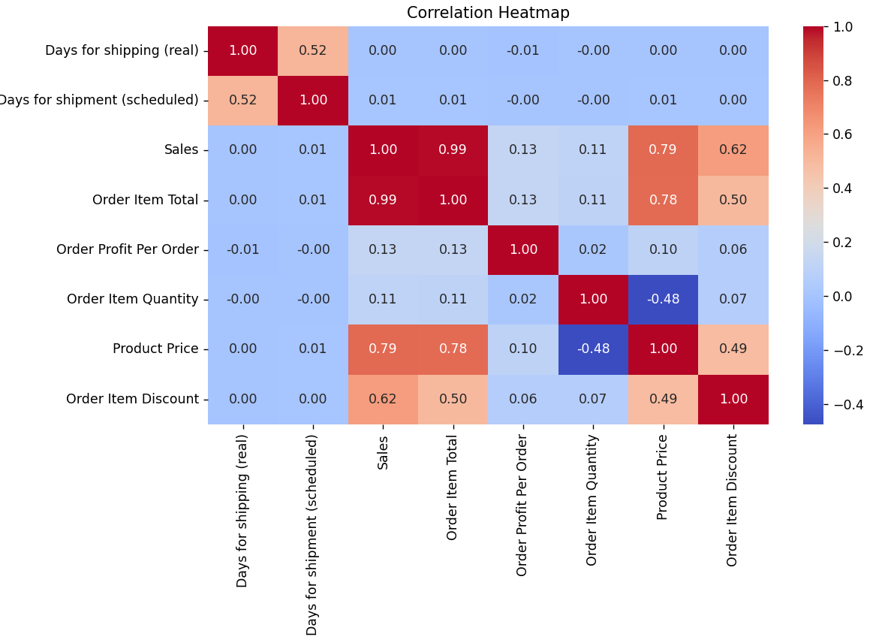6. Delivery Performance Analysis
Delivery performance was evaluated using the Late_delivery_risk column. Records with a value of 0 were treated as on-time deliveries, while records with a value of 1 were treated as late deliveries for the KPI calculation.
Key Performance Indicators
KPI | Result
On-Time Delivery Rate | 45.17%
Late Delivery Rate | 54.83%
Average Actual Shipping Time | 3.50 days
Average Shipping Delay | 0.57 days
Total Order Profit | 3,966,902.97
Analysis
The on-time delivery rate was 45.17%, whereas the late-delivery rate was 54.83%. This indicates that late deliveries represented a significant challenge in the dataset.
The average actual shipping time was 3.50 days. The average shipping delay was 0.57 days, calculated by subtracting scheduled shipping days from actual shipping days.
A positive shipping delay indicates that actual shipping took longer than scheduled. These results highlight the importance of monitoring shipping schedules and identifying the factors associated with delivery delays.
Visualization 2: Average Actual vs. Scheduled Shipping Days
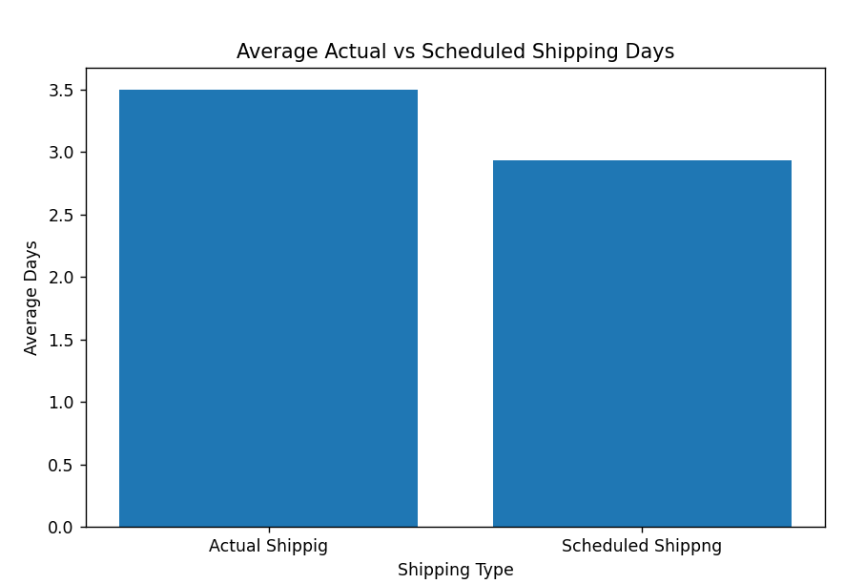

Visualization 3: Distribution of Delivery Status
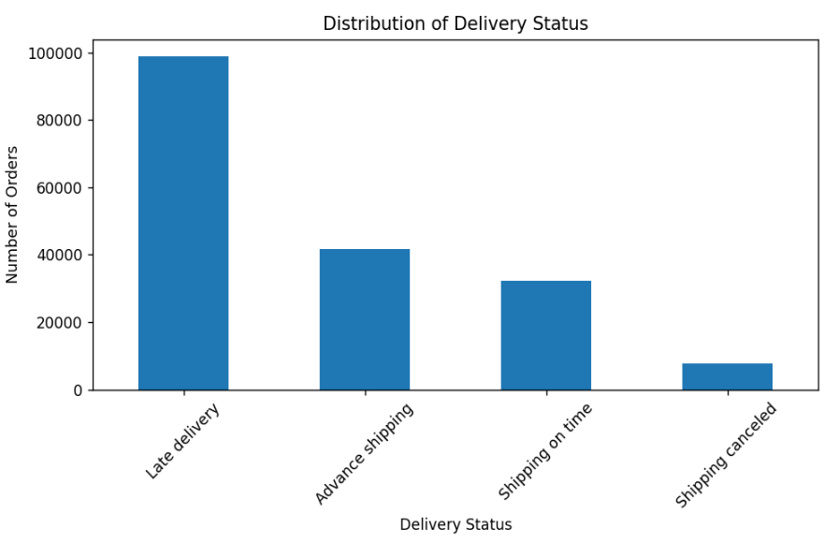
7. Sales and Shipping-Mode Analysis
Sales were grouped by shipping mode to compare the contribution of First Class, Same Day, Second Class, and Standard Class.
Sales by Shipping Mode
Shipping Mode | Total Sales (approx.)
First Class | 5,674,370
Same Day | 1,942,529
Second Class | 7,145,445
Standard Class | 22,022,390
Analysis
Standard Class generated the highest total sales, at approximately 22.02 million. Second Class generated approximately 7.15 million, followed by First Class at 5.67 million. Same Day recorded the lowest sales, at approximately 1.94 million.
This comparison shows that Standard Class accounted for the largest sales contribution among the shipping modes in the dataset.
Visualization 5: Total Sales by Shipping Mode
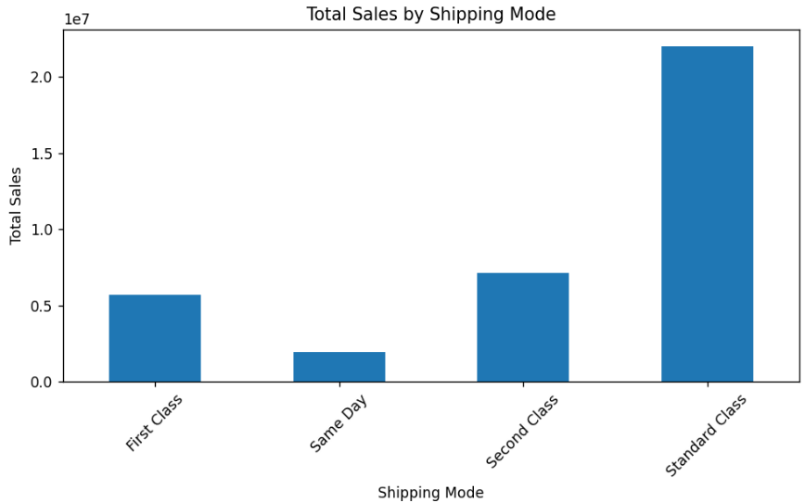

Sales Distribution
A histogram was created to examine how sales values were distributed across orders. This visualization helps identify whether sales values are concentrated within particular ranges or whether some orders have much higher values than others.
Visualization 6: Sales Distribution Histogram
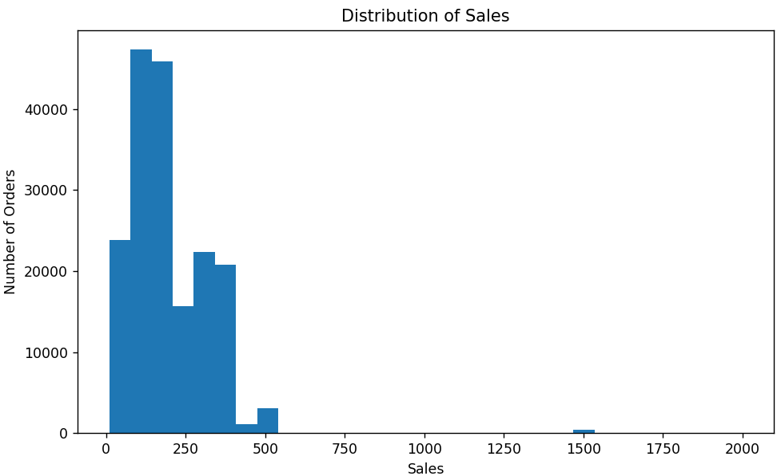
Sales vs. Product Price
A scatter plot was created to examine the relationship between product price and sales. Each point represents an observation in the dataset.
This visualization helps assess whether higher product prices tend to occur alongside higher sales values. The actual relationship should be interpreted from the plotted data rather than assumed in advance.
Visualization 7: Sales vs. Product Price
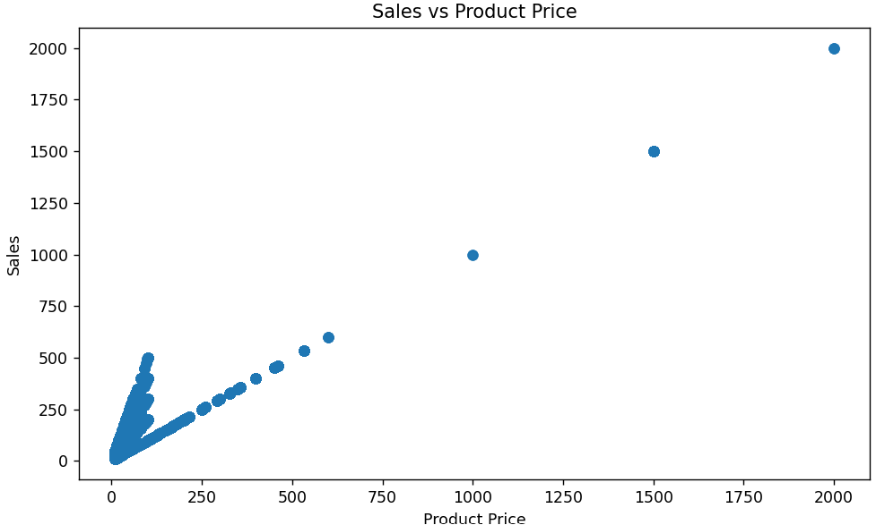
8. Late-Delivery Analysis by Shipping Mode
The number of total orders and late orders was calculated for each shipping mode. The late-delivery rate was then calculated as:
Late-Delivery Rate = (Late Orders / Total Orders) × 100
Shipping Mode | Total Orders | Late Orders | Late-Delivery Rate
First Class | 27,814 | 26,513 | 95.32%
Second Class | 35,216 | 26,987 | 76.63%
Same Day | 9,737 | 4,454 | 45.74%
Standard Class | 107,752 | 41,023 | 38.07%
Analysis
First Class had the highest late-delivery rate at 95.32%, followed by Second Class at 76.63%. Same Day had a late-delivery rate of 45.74%, while Standard Class had the lowest rate at 38.07%.
Although Standard Class handled the highest number of orders, its late-delivery rate was lower than that of the other shipping modes. First Class and Second Class should therefore receive particular attention in further investigations into delivery delays.
9. Market-Wise Delivery Analysis
The dataset was grouped by Market to calculate total orders, late orders, total sales, and total profit. The late-delivery rate was calculated for each market.
This analysis helps compare delivery performance across markets and identify locations that may require closer investigation.
Purpose of the Analysis
- Compare late-delivery rates across markets.
- Identify markets with a high proportion of late orders.
- Compare sales and profit across markets.
- Support decisions about where additional logistics analysis may be required.
Market-Wise Findings: Insert the highest and lowest late-delivery rates and relevant sales and profit results from the program output.
10. Region-Wise Delivery and Shipping-Delay Analysis
The dataset was grouped by Order Region to calculate total orders, late orders, total sales, and total profit.
A separate regional shipping-delay analysis calculated average delay, maximum delay, and total orders for each region.
Analysis
The region-wise analysis helps identify differences in delivery performance across regions. Comparing average and maximum shipping delays can help identify areas where actual shipping times differ from scheduled times.
The results can also help prioritize regions for further investigation. However, a high late-delivery rate alone does not identify the cause of a delay; additional analysis of shipping schedules, order characteristics, and operational factors may be necessary.
High-Risk Region Analysis
Regions with a late-delivery rate greater than 50% were classified as high-risk regions in the code.
This threshold was used as an analytical rule to identify regions that may need additional attention. The resulting list should be reviewed to determine which regions have the highest late-delivery rates.
High-Risk Findings: Insert the region names and late-delivery rates printed by the program.
11. Product Category Analysis
Product categories were analyzed using Category Name. The analysis calculated total orders, total sales, total profit, and average profit for each category.
Category-Wise Sales and Profit
This analysis helps compare product categories based on their contribution to sales and profit. Categories with high total sales may be important to overall business performance, while categories with high total profit may be particularly valuable from a profitability perspective.
Visualization 11: Top 10 Product Categories by Sales
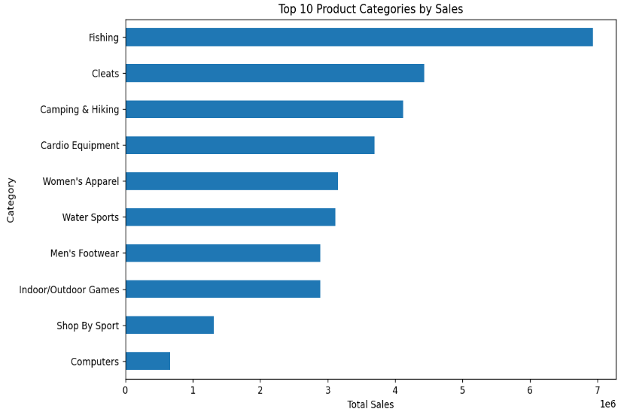
Visualization 12: Top 10 Product Categories by Profit
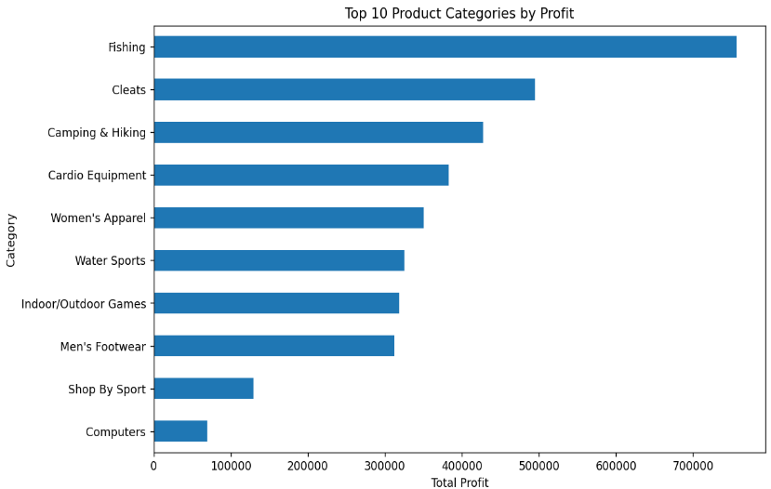
Category-Wise Late-Delivery Analysis
The number of orders and late orders was calculated for each product category. The late-delivery rate was then calculated to compare delivery performance across categories.
This analysis helps identify categories with relatively high late-delivery rates. These categories can be investigated further to determine whether delivery problems are associated with order characteristics or other logistics factors.
Category-Wise Findings: Insert the categories with the highest late-delivery rates from the program output.
12. Key Findings
The completed analysis produced the following findings:
- The overall late-delivery rate was 54.83%, exceeding the on-time delivery rate of 45.17%.
- Average actual shipping time was 3.50 days, and average shipping delay was 0.57 days.
- Standard Class generated the highest total sales and handled the largest number of orders.
- First Class had the highest late-delivery rate among the four shipping modes.
- Second Class also had a high late-delivery rate and requires further investigation.
- Market-wise and region-wise analysis provides a basis for identifying geographical differences in delivery performance.
- Category-wise analysis allows product categories to be compared by sales, profit, and late-delivery rate.
- Visualizations make it easier to compare performance and communicate important patterns in the dataset.
13. Recommendations
Based on the analysis, the following recommendations are proposed:
- Investigate the high late-delivery rates in First Class and Second Class.
- Monitor on-time delivery, late-delivery rate, and average shipping delay regularly.
- Review the difference between actual and scheduled shipping days.
- Compare delivery performance across markets and regions to prioritize further investigation.
- Evaluate product categories based on both profitability and delivery performance.
- Use visual dashboards to communicate key logistics KPIs clearly.
- Continue with predictive analysis to investigate factors associated with delivery delays.
- Explore route and logistics optimization only after examining the available route-related data and relevant operational constraints.
14. Conclusion
During Week 3, advanced data analysis and visualization were conducted using the cleaned DataCo Supply Chain Dataset. The analysis covered descriptive statistics, correlations, delivery KPIs, sales distribution, shipping-mode performance, market-wise and region-wise delivery analysis, high-risk region identification, and product category performance.
The results showed that late delivery was a major issue in the dataset. First Class and Second Class had particularly high late-delivery rates, while Standard Class generated the highest sales and handled the largest number of orders.
The charts and statistical summaries provide a clear way to communicate these findings and identify areas requiring further investigation. This work establishes a foundation for subsequent predictive modeling and logistics improvement activities.

